**Racial Wealth Gap Learning Simulation Tracking Card**

*Please put your name on your assigned “race”*

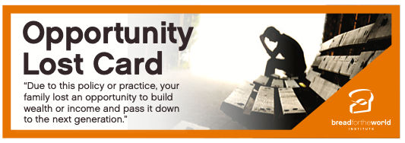

Return

Pick Up

Return

Pick Up

Return

Pick Up

With each policy that is read, each participant will be able to make an action: Money, Land, and Lost Opportunity. Your action is based on being “white” or “black.” Make a mark in the box based on what you are able to do based on your “race.” Please use a pencil.