Michigan

A Hunger and Poverty Snapshot

Between 2019-2021:
- Food insecurity in Michigan averaged 11.4%.
- Michigan’s food insecurity rate was 9% higher than the national average of 10.4%.
- The official poverty rate (which does not account for income from safety-net and tax-support programs such as SNAP, EITC, and others) in the state averaged 11.0%.
- But using the Supplemental Poverty Measure (which does include safety-net and tax-support income), the poverty rate falls to 7.6%. In other words, these programs reduced the poverty rate in Michigan by 31% and the number of people living in poverty by 335,000.
- SNAP, alone, lifted 272,000 people above the poverty line in Michigan, including 112,000 children, per year between 2013 and 2017, on average.

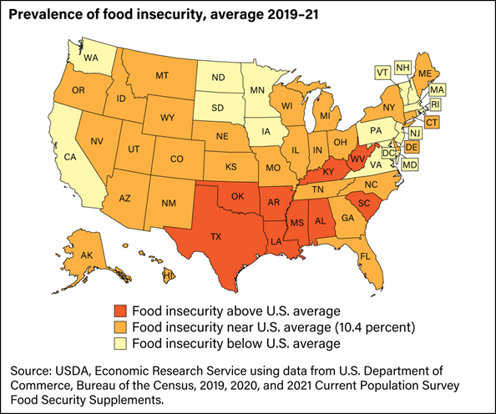 | Nutrition and Health  Diabetes and other diet-related health costs in Michigan were estimated to be $9.7 billion per year in 2017.  12.3% of the adult population in Michigan has been diagnosed with diabetes in 2020. This includes:  - 23.6% of seniors.  - 16.7% of Black adults.  - 20% of adults with incomes of less than $25,000.  Every year an estimated 59,300 adults in Michigan are diagnosed with diabetes.  Only 11.1% of adults in the state are meeting recommended fruit intake and 7.2% recommended vegetable intake.

Why Bread for the World is Focused on the Farm Bill

The Farm bill is scheduled to be reauthorized in 2023. No legislation has more impact than a farm bill on the US food system and the nation’s ability to provide healthy food at affordable prices to everyone.

Bread for the World’s farm bill priorities include a focus on nutrition, equity, and sustainability. We believe Michigan has a lot to gain from a farm bill legislated with these priorities in mind.

Nutrition | Equity | Sustainability
Bread for the World supports strengthening SNAP in Michigan.  Not only is SNAP the flagship food security and nutrition program, it is indispensable to better health outcomes and economic prosperity.  In 2021, 13% of Michigan residents were helped by SNAP.  - Roughly 461,400 workers in Michigan live in households that participated in SNAP in 2021.  - SNAP helps 1 in 10 workers in Michigan put food on the table.  - 61% of SNAP participants were in families with children, and 41% in families with members who are older adults or are disabled.  - 90% of all SNAP-eligible people in Michigan participate in the program. | Bread for the World supports farm policies that promote a more equitable food system in Michigan.  The Michigan population is 79% white. According to the most recent Census of Agriculture, 98% of farmers and ranchers (producers) in Michigan are white and occupy 99% of all farmland.  - Black producers represent >1% and occupy >1% of farmland.  - Hispanic producers represent 1% and occupy >1% of farmland.  - Indigenous producers represent >1% and occupy >1% of farmland. | Bread for the World is committed to eradicating food insecurity by building a more sustainable food system in Michigan.  Reducing unnecessary food waste is one way to build a more sustainable food system.  In 2019, 2.38 million tons of surplus food in Michigan went to waste instead of reaching those who needed it, an amount equal to:  - 3.84 billion meals unsold or uneaten.  - $10.9 billion in lost sales.  - Annual CO2 emissions produced by 1,719,444 gasoline-powered cars.,

Footnotes

https://www.ers.usda.gov/webdocs/publications/104656/err-309.pdf?v=9924.5
Bread for the World, based on USDA reporting, See Note 1.
https://www.census.gov/content/dam/Census/library/publications/2022/demo/p60-277.pdf
https://www.census.gov/content/dam/Census/library/publications/2022/demo/p60-277.pdf
https://www.census.gov/content/dam/Census/library/publications/2022/demo/p60-277.pdf
https://www.cbpp.org/research/food-assistance/a-closer-look-at-who-benefits-from-snap-state-by-state-fact-sheets#Michigan
https://diabetes.org/about-us/statistics/by-state
https://www.americashealthrankings.org/explore/annual/measure/Diabetes/state/MI
https://diabetes.org/about-us/statistics/by-state
https://www.cdc.gov/mmwr/volumes/71/wr/mm7101a1.htm?s_cid=mm7101a1_w#T1_down
https://www.cbpp.org/research/food-assistance/a-closer-look-at-who-benefits-from-snap-state-by-state-fact-sheets#Michigan
https://www.cbpp.org/snap-helps-low-wage-workers-in-every-state#Michigan
https://www.cbpp.org/snap-helps-low-wage-workers-in-every-state#Michigan
https://www.cbpp.org/research/food-assistance/a-closer-look-at-who-benefits-from-snap-state-by-state-fact-sheets#Michigan
https://www.fns.usda.gov/usamap
https://www.nass.usda.gov/Publications/AgCensus/2017/Full_Report/Census_by_State/Michigan/
https://insights-engine.refed.org/food-waste-monitor?break_by=food_type&indicator=tons-surplus&view=detail&year=2019
https://insights-engine.refed.org/food-waste-monitor?break_by=food_type&indicator=tons-surplus&view=detail&year=2019
https://insights-engine.refed.org/food-waste-monitor?break_by=food_type&indicator=tons-surplus&view=detail&year=2019
https://insights-engine.refed.org/food-waste-monitor?break_by=food_type&indicator=tons-surplus&view=detail&year=2019
https://www.epa.gov/energy/greenhouse-gas-equivalencies-calculator

